**Project A: A Little Robots and butterflies in the Starry Night**

***CompSci 351-1: Intro to Computer Graphics* *Fall 2021***

Student Name: Jiaqi Guo NetID: JGR9647

* **Project Description**

1. ***Project Goal:*** In this project we are going to construct a Moving, Jointed 3D Assemblies using WebGL. To be more specific, we have to build a collection of several different, visually distinctive rigid 3D parts. These 3D parts are then linked into several kinds of animated, jointed 3D assemblies through a series of 3D transformations (e.g. modelMatrix) and drawing calls. Besides, those moved assemblies should be able to move smoothly and continuously without users’ command, but also respond to users’ mouse & keyboard and GUI controls.
2. 图片包含 飞行, 室内, 鸟, 风筝

   描述已自动生成***Project Detail:*** The project consists of four kinds of 3D rigid assemblies, which are the *twinkling stars*, the *moon*, *4 flying butterflies* and *small robots* swimming in the night sky.

Among them, the small robot will follow the user-determined-orbit to carry out periodic movements. The moon's position cannot be changed, but users can drag the moon (with your mouse) around to find their favorite angle. And the butterflies will be flying irregularly around the little robot.

**Figure 1 Chrome Screenshot for This Project**

Finally, one of the highlights of the project is the constant twinkling of stars in the night sky. Each star is an independent 3D rigid part, and each star has its unique position and size as well as rotation sensitivity. Users can control the number of stars appearing on each frame of the canvas simply by entering a specific positive number **“N”** into the browser interface (take the above Figure 1 as example, the user’s input is **N = 4** ). For the *transient effect of the human eye*, users might see many stars flashing on the canvas at the same time, which is, in fact, larger than **“N”** that user defined.

* **A Quick User Guide**
* ***FUNCTION 1: Creating the Sparkling Stars***
  1. ***What is it? :*** This function enables the user to determine the number N of stars that appears on *each frame* of the canvas, and these stars of different sizes will be everywhere on your canvas. The larger the number you enter, the more stars will appear at the same time.
  2. ***How to control? :*** Just enter the number you want in the input box, and then press the *“Submit the number”* button.
  3. ***Attention:*** The number you entered should be a *non-negative integer*, and *do not enter 1 for your first input* or nothing will happen, since each reload of this program will reset this number to 1(initial states).
* ***FUNCTION 2: Rotating the Moon with Your Mouse***

1. ***What is it? :*** This function enables the user to rotate the moon and the star simultaneously.
2. ***How to control? :*** Drag the moon in the upper left corner of the canvas and you will find that both the moon and the stars rotate at different angles (see Figure 1 as example). Press the *“Reset the change to the moon”* button to reset the rotation angle.
3. ***Attention:*** The stars also rotate when you drag the mouse, but it may not be easy to observe because they are twinkling all the time.

* ***FUNCTION 3: Controlling the Movement of the Little Robot***

1. 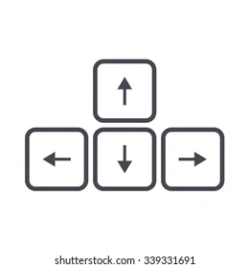***What is it? :*** This function enables the user to *control the position* of the small robots with simply pressing the arrow keys (Figure 2) on the keyboard.

**Figure 2 The Arrow Keys**

1. ***How to control? :*** Pressing the left arrow will make the small robot move to the left, and the right arrow will make the small robot move to the right. Similarly, the up and down arrows will control the small robot to move up and down respectively. And Pressing R on the keyboard will *reset* your little robot to its original orbit
2. ***Attention:*** If you accidentally move the robot out of the canvas, press R to reset the robot's position.

* ***FUNCTION 4: Controlling the Speed of the Movement***

1. ***What is it? :*** This function enables the user to *control the speed* of the little robot and butterflies when it is moving on the canvas.
2. ***How to control? :*** Pressing the *“Travel in directing <<”* to make the small robot/butterflies *move clockwise*, press *“Travel in direction >>”* to make the small robot/butterflies *move counterclockwise*. Also, *stop/restart* the small robot/butterflies’ movement by pressing the *“Run/Stop”* button.

* **Result Explanation**

1. ***Example: Flashing Stars***

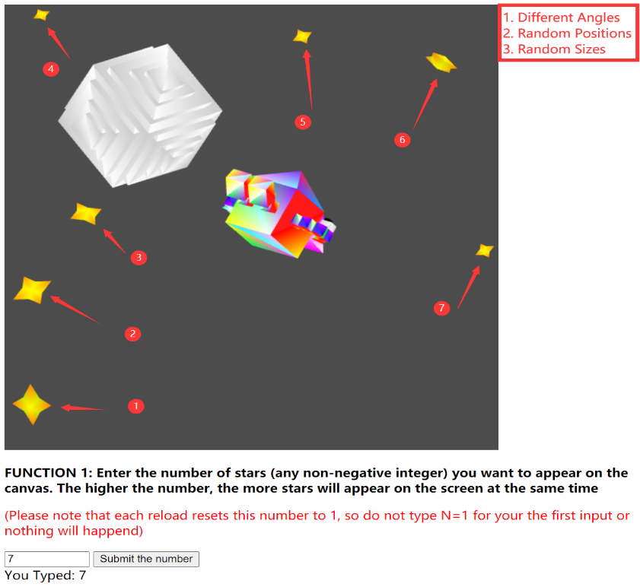

In this example, we will show the several features of my project, where we set the number of stars to 7 and click the “Submit the number” button.

Here we use a screenshot to capture a frame of the animated canvas, as shown in the Figure 3 where 7 stars appear on one screen, each with different sizes and different positions. That is because, here, we use a set of random numbers to determine the position and size of the star.

At the same time, we can also observe from the figure that each star has a different rotation angle. This is because we multiplied its change rate by a special change coefficient when calculating the angle, which changed the sensitivity of each star to mouse drag, making them present different angles on the canvas.

**Figure 3 Basic 3D Star Model with its Various Transformation**

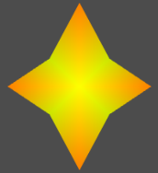

**Figure 4 Screen Capture for Function 1 (input N = 7)**

Above, from left to right, are the basic 3D rigid shape of the star and its various transformations. This is also *the first 3D part* that designed by me.

1. ***Example: Two 3D Jointed, Moving Assemblies***

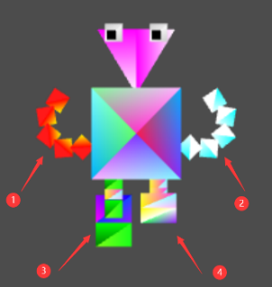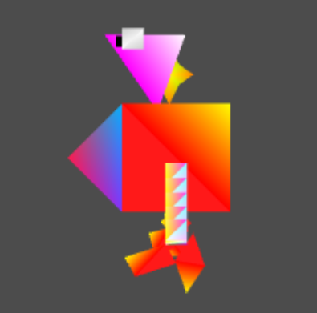

**Little Robot -** The first rigid 3D assembly is our little robot, which has five and three joints in its hands and feet and can swing up and down at completely different speeds and directions of movement. Its belly is *the second 3D part we designed*, which contains 9 faces and 9 vertices.

**Figure 5 The little robot (Front view and side view)**

**Flying Butterfly –** This is the second rigid 3D assembly that I design, which have four wings that can flap periodically. In this project, a total of four flying butterflies will appear at the same time. They are of different sizes and have different flight trajectories and speeds. The body of each butterfly is an irregular spindle with 6 vertices and 8 faces, which is *the third basic 3D part* that I designed.

**Figure 6 A Sample of the Butterfly**

**The Moon & Stars –** which are the third and fourth rigid 3D assemblies that I built. *The Moon* is combined by 19 cubes. Unlike the other two assemblies above, this one does not have any joints and does not move on its own. Users need rotate it using their mouse.

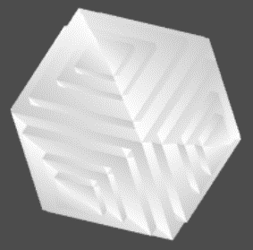

As for *the Star* shape, it is an independent 3D shape which consists of 16 faces and 10 vertices.

**Figure 7 The Moon and Star Shape**

1. ***Example: Move the little Robot with keyboard***

**Figure 8 Shift the Little Robot with the Arrow Keys**

**From left to right: (1). Origin Position (2). Upper Shifting (3). Left Shifting**

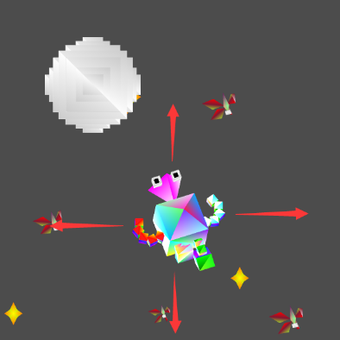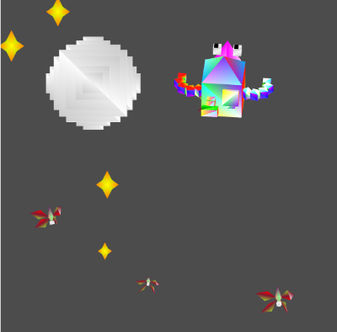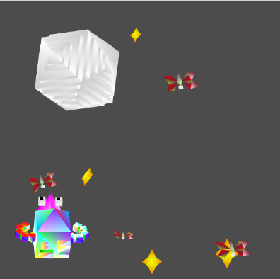

In this example, we use three pictures to show how we control the small robot to move on the canvas with the keyboard. The first picture on the left is the original position of the small robot. In the middle figure, we move it trajectory up, and in the third picture, we move its trajectory to the left.

* **Scene Graphs for Two 3D Assemblies in This Project**

**Figure 9 The Scene Graph for the 3D Assemblies (Little robot & Butterflies)**

